**Key Figure - DSAI Student Project – “Intelligent AOM” Leo Forster & Jonas Henker**

Project Donor: Prof Dr. Jürgen Eschner & team (Experimental Physics - Quantum Photonics)

**Key figure:** The key figure shows the two discrete frequency spectra, the first is the input of the arbitrary wave generator (**AWG**), the second is the spectrum of the laser after passing through the acoustic-optical modulator (**AOM**), measured by two photodetectors in combination with a beam splitter.

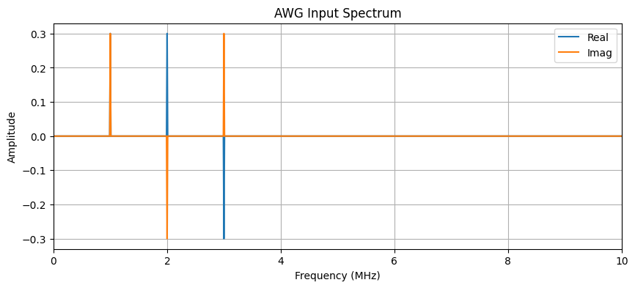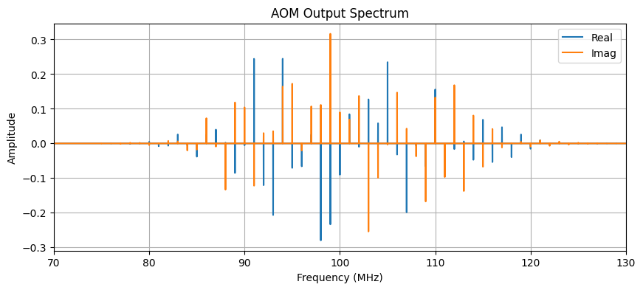

**Objective of this figure:** The objective of this figure is to show, how a machine learning model can be used, to obtain a simple frequency configuration (*AWG Input Spectrum*) to produce a desired output spectrum*,* given a rather complex, discrete laser spectrum (*AOM Output Spectrum*)*.*

**Unit of observation:** Discrete frequency spectrum f’ of AOM for given, constant input frequency f of the laser and a non-linear interference v (unknown, learned by model).  
Given by the Fast-Fourier-Transform (**FFT**), the spectra contain real as well as imaginary components.

**Unit of measurement:** MHz

**Time window of observation:** Continuous real-time monitoring during experiment runtime

**Overall description of this figure:** The figure shows the input and expected output of the machine learning model. The model will get a desired *AOM Output Spectrum* as input and calculate the required *AWG Input Spectrum*, which then will be used to configure the AWG accordingly.   
The AWG then modulates the laser, which has a constant frequency, via the AOM. After this, the laser should have the desired, complex spectrum, which was given as input of the model.  
A complex model is needed, since the input-output relation is typically non-linear.   
Once trained, the model operates in a closed-loop system, continuously receiving photodetector input and adjusting the RF signal to the AOM through an arbitrary waveform generator (AWG).

**Y-Axis:** Amplitude (-1 to 1 for both)

**X-Axis:** MHz (-5 to 5 MHz for AWG Input Spectrum, 50 to 150 MHz for AOM Output Spectrum)

**Legend:**   
“Real” - real components of FFT-Frequency bins (blue)  
“Imag” - imaginary components of FFT-Frequency bins (orange)

**Data processing required:**

1. Meta parameter selection: frequency-range for in- and output, number of frequency-bins, amplitude-range, carrier-frequency (constant frequency of laser)
2. Selection of AOM-model: We will simulate the AOM modulation with different, nonlinear AOM simulations. Thus, we need to preselect, different, viable AOM-models.
3. Sourcing of training data: We source the training data, by simulating different AWG-frequency-configurations on the AOM-models. Here we can already work with higher frequency-resolutions, so that a later re-simulation is not needed.
4. Frequency-domain transformation: We transform the continuous, time-based signals via the Fast-Fourier transform into discrete frequency spectra and vice versa.
5. Model architecture selection: We select the model architecture, which performs the best over all the different AOM-simulations, so that it will adapt the best to the real experiment-data when deployed.